WEEK – 2 : JUNIT_BASIC TESTING EXERCISES
EXERCISE 1: SETTING UP JUNIT
CODE IMPLEMENTATION

Main Class: Calculator.java

package com.example;

public class Calculator {
public int add(int a, int b) {
return a + b;
}
}

Test Class: CalculatorTest.java
package com.example;

import static org.junit.Assert.*;
import org.junit.Test;

public class CalculatorTest {

@Test
public void testAdd() {
Calculator calc = new Calculator();
int result = calc.add(5, 3);
assertEquals(8, result);
}
}

OUTPUT
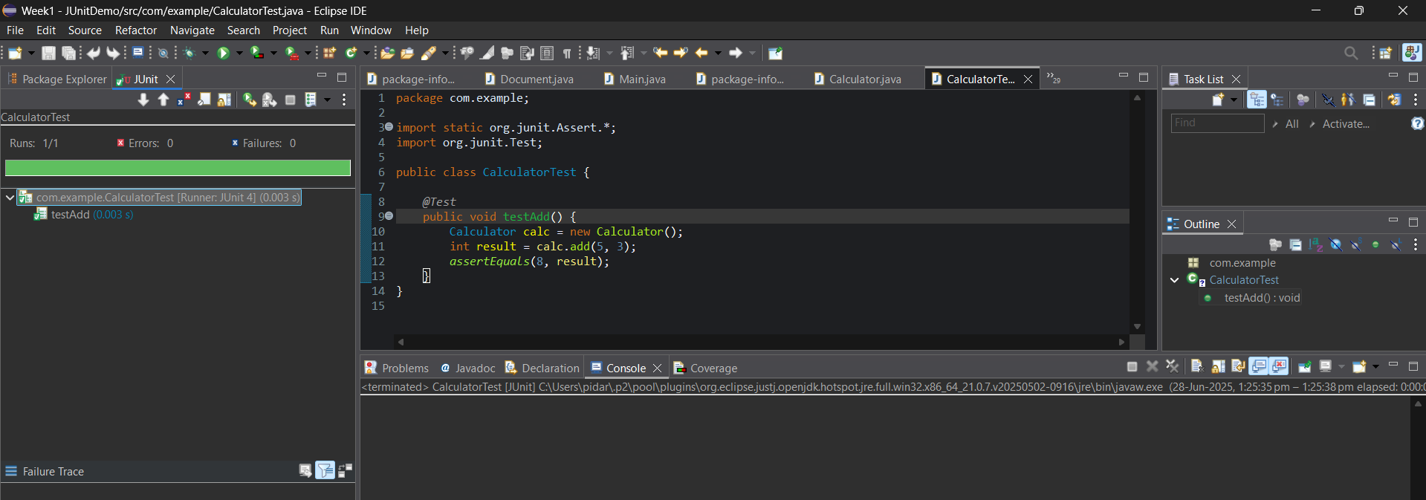

EXERCISE 3: ASSERTIONS IN JUNIT
CODE IMPLEMENTATION
AssertionsTest.java

package com.example;

import static org.junit.Assert.*;
import org.junit.Test;

public class AssertionsTest {

@Test
public void testAssertions() {
assertEquals(5, 2 + 3);
assertTrue(5 > 3);
assertFalse(5 < 3);
assertNull(null);
assertNotNull(new Object());
}
}

OUTPUT
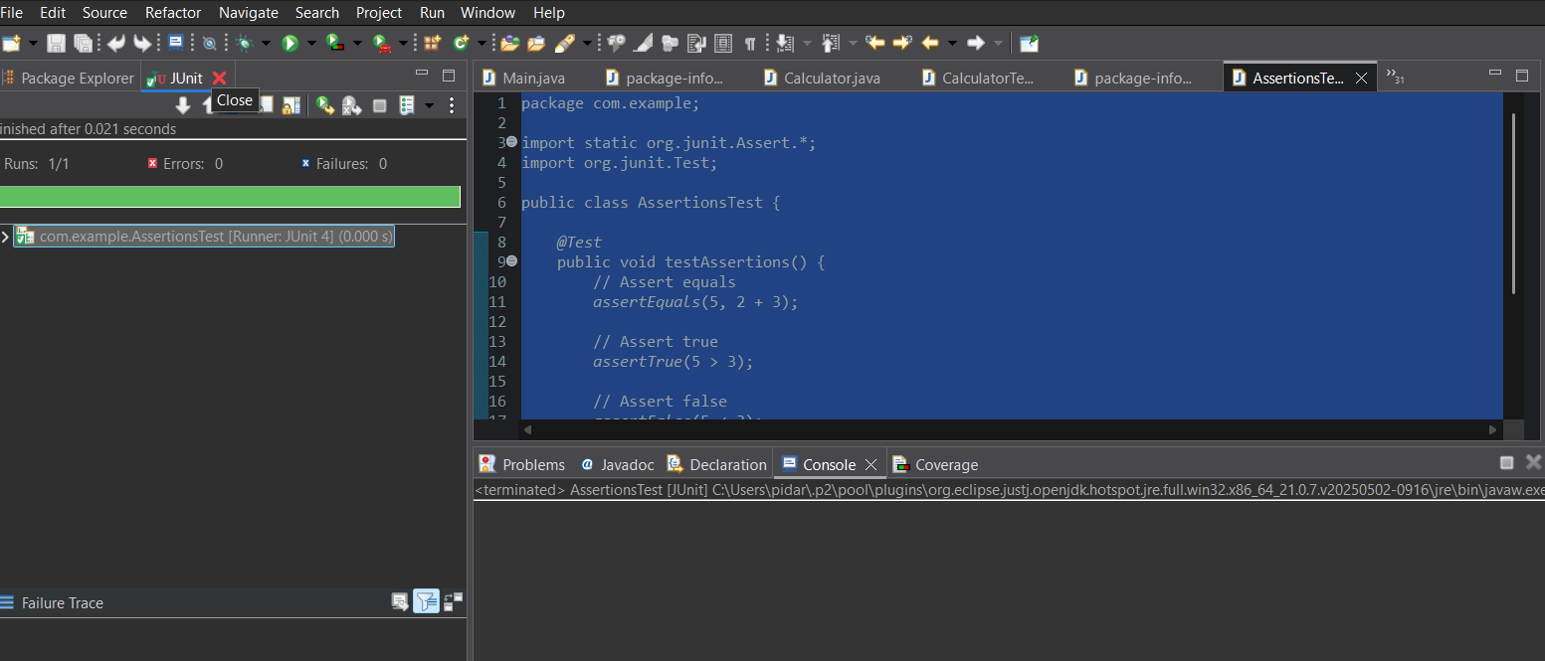

EXERCISE 4: ARRANGE-ACT-ASSERT (AAA) PATTERN WITH SETUP AND TEARDOWN IN JUNIT
CODE IMPLEMENTATION
Calculator.Java
package com.example;

public class Calculator {
public int add(int a, int b) {
return a + b;
}
public int subtract(int a, int b) {
return a - b;
}
}

CalculatorTest.Java
package com.example;

import static org.junit.Assert.*;
import org.junit.Before;
import org.junit.After;
import org.junit.Test;

public class CalculatorTest {

private Calculator calculator;

@Before
public void setUp() {
calculator = new Calculator();
System.out.println("🔧 Setup: Calculator initialized");
}

@After
public void tearDown() {
calculator = null;
System.out.println("🧹 Teardown: Calculator cleaned up");
}

@Test
public void testAdd() {
int a = 5, b = 3;
int result = calculator.add(a, b);
assertEquals(8, result);
}
public void testSubtract() {
int a = 10, b = 4;
int result = calculator.subtract(a, b);
assertEquals(6, result);
}
}

OUTPUT
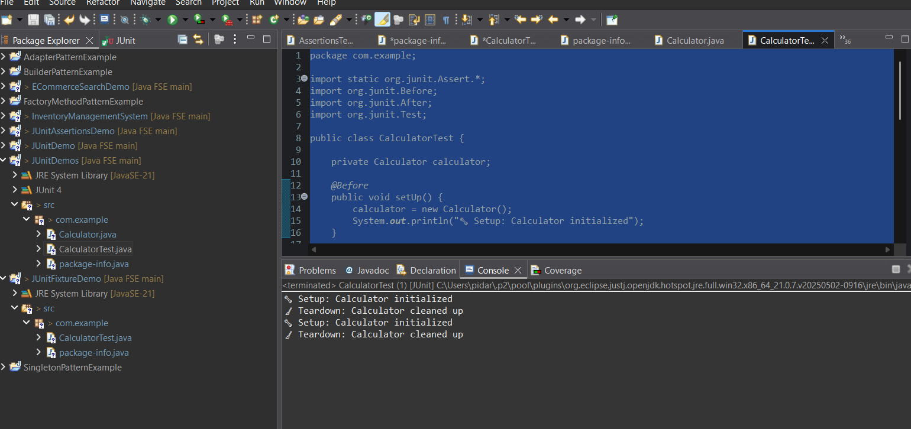

WEEK 2: MOCKITO EXERCISES
EXERCISE 1: MOCKING AND STUBBING
Step 1: Create a java maven project in eclipse.
Step 2: Update the pom.xml file and update the Maven project.
Step 3: Create a ExternalApi.java in src/main/java
package com.example;

public interface ExternalApi {
String getData();
}

Step 4: Create a Service.java file in src/main/java
package com.example;

public class MyService {
private ExternalApi externalApi;

public MyService(ExternalApi externalApi) {
this.externalApi = externalApi;
}

public String fetchData() {
return externalApi.getData();
}
}

Step 5: Create a ServiceTest.java file in src/test/java
package com.example;

import org.junit.jupiter.api.Test;
import org.mockito.Mockito;

import static org.mockito.Mockito.*;
import static org.junit.jupiter.api.Assertions.*;

public class MyServiceTest {

@Test
public void testExternalApi() {
// Step 1: Create mock
ExternalApi mockApi = Mockito.mock(ExternalApi.class);

// Step 2: Stub method
when(mockApi.getData()).thenReturn("Mock Data");

// Step 3: Use mock in service
MyService service = new MyService(mockApi);
String result = service.fetchData();

// Step 4: Assert the result
assertEquals("Mock Data", result);
}
}

OUTPUT
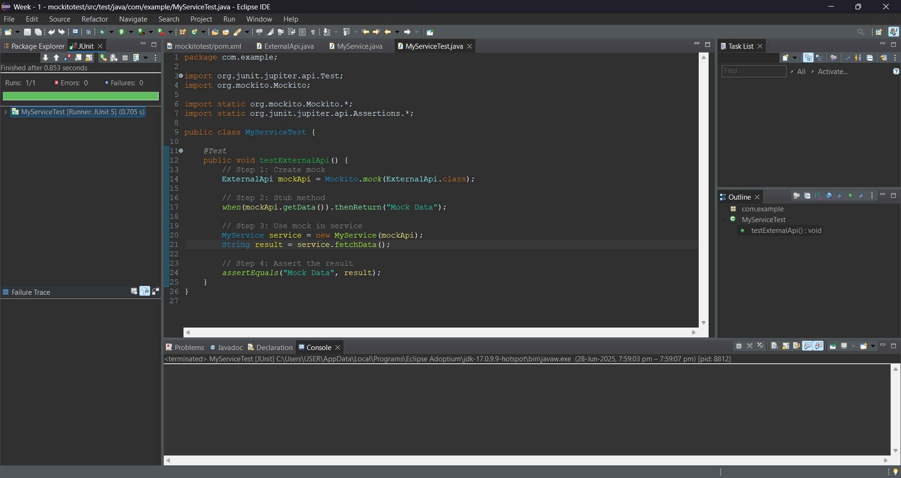

EXERCISE 2: VERIFYING INTERACTIONS
Step 1: Create a java maven project in eclipse.
Step 2: Update the pom.xml file and update the Maven project.
Step 3: Create a ExternalApi.java in src/main/java
package com.example;

public interface ExternalApi {
String getData();
}

Step 4: Create a Service.java file in src/main/java
package com.example;
public class MyService {
private ExternalApi api;

public MyService(ExternalApi api) {
this.api = api;
}

public String fetchData() {
return api.getData();
}
}

Step 5: Create a ServiceTest.java file in src/test/java
package com.example;

import org.junit.jupiter.api.Test;
import org.mockito.Mockito;

import static org.mockito.Mockito.*;

public class MyServiceTest {

@Test
public void testVerifyInteraction() {
// Step 1: Mock the ExternalApi
ExternalApi mockApi = Mockito.mock(ExternalApi.class);

// Step 2: Pass mock to service
MyService service = new MyService(mockApi);
service.fetchData();

// Step 3: Verify that getData() was called
verify(mockApi).getData();
}
}

OUTPUT
